UAT Replication of MIS Report not having Camping code

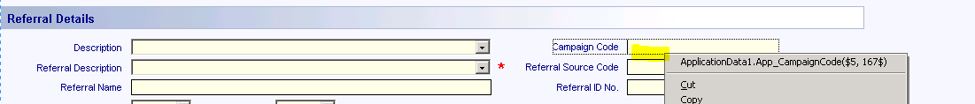

**Step1: Creating Camping code in UAT as in PROD**

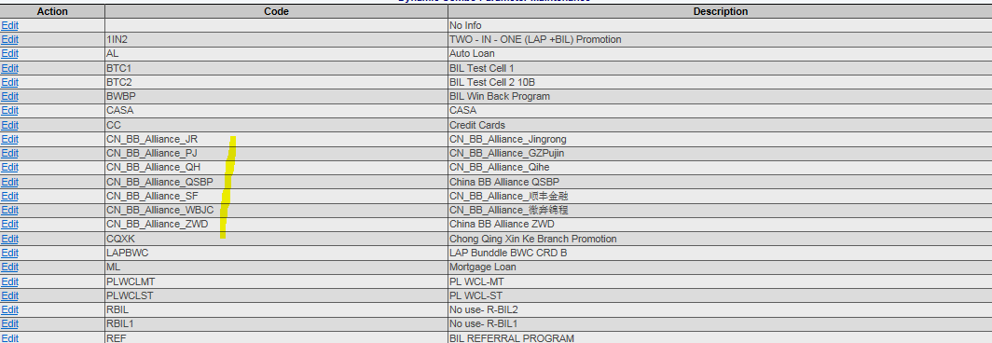

Root Cause:

**Step2: Whatever selection in the Description based on CN_BB_ ALLIANXXXXXXX, Campaign code is taken only CN_BB_ALLIAN**

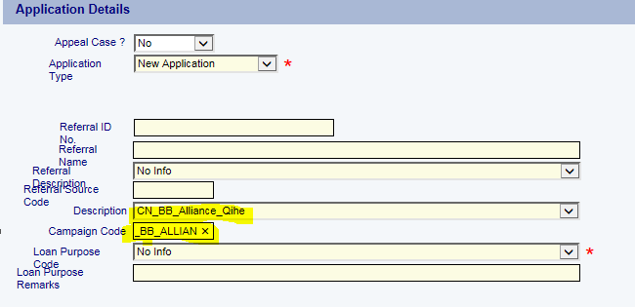

**Step3: Why in Report the Campaign code is empty**

SP: [sp_pivot_MIS_by_county_sel#dt2] this is the procedure to generate the campiang code

Condition in SP:

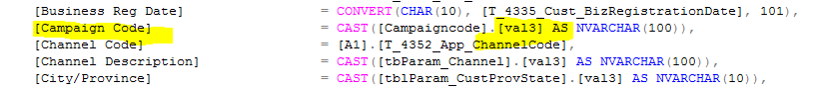

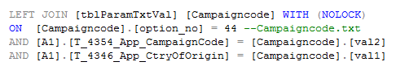

Create query based on my application number and Result. So this is the reason campaign code is empty in Report

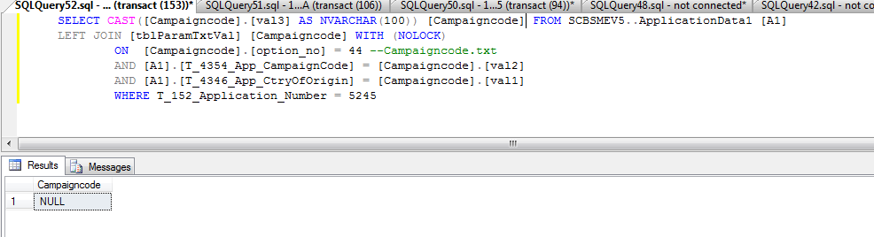

Application screen:



Checking in MIS Report:

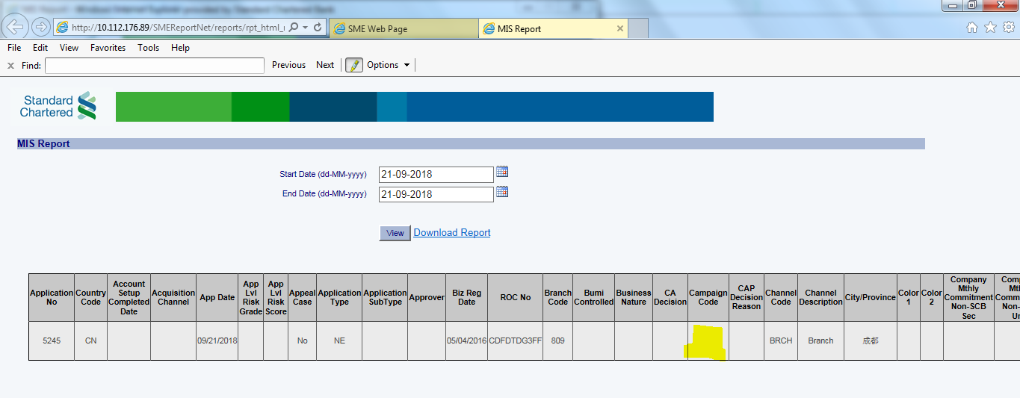

Design Studio check the length:

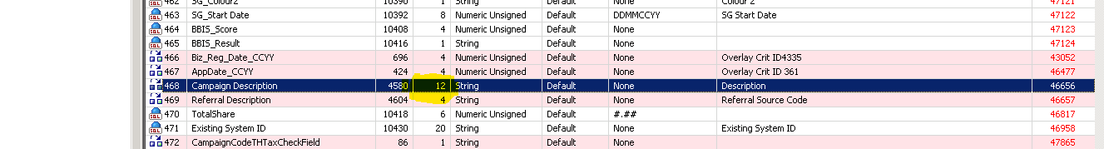

Solution:

In design studio need to increase the length as 24 up-to 100 for campaign description.

Design Studio page1: **“CNInitAppFormCorpIndv”**

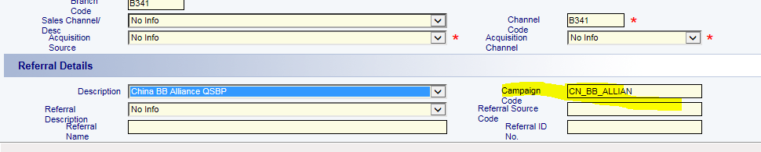

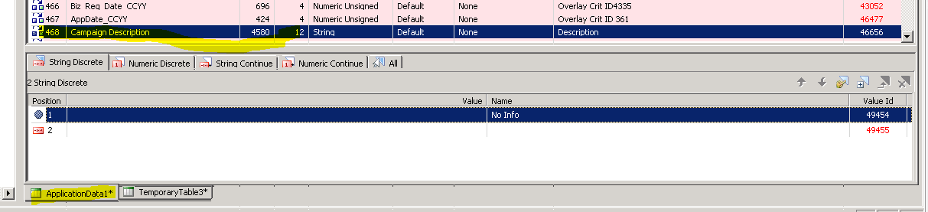

Design Studio Page2: **“Application Detail”**